General Instructions:
- Complete a Benefit Report for every client referral.
  - Write the Benefit Report, even if the person is on Path 3 of the Decision Guide and will need a full Benefit Summary and Analysis (BS&A). Use the “BS&A Required Benefit Report” template.
  - Share a copy of the report with the referral source (e.g., VR Counselor) and the person.
- The Benefit Report is a template. It includes all of the most common information related to benefits and work.
Be sure to:
  - Delete information or entire sections of this report that are not applicable to the client.
  - Read through the ENTIRE document before printing or sharing to make sure all template text has been removed.
- It is important to begin with a new template rather than editing one previously saved when creating a new Benefit Report.
- Use the “Find & Replace” feature to easily find the brackets [ ] and enter the correct information throughout the entire document.
- This document has been made accessible (alt text descriptions have been added to the charts and text boxes). However, if you are working with a person who uses a screen reader or other device to help with reading/vision, it is recommended you remove the charts and text boxes and simply type the information as text in the Word document.

Section-by-section Instructions:

Cover Page “Snapshot”
- Enter the client’s name, your agency name, and your name
- Enter the reason a BS&A is needed and the name of the Hub CPWIC who will be writing the BS&A in the text box.

Your Current Situation & Work Plans Section
- Your Current Benefits:
  - List all of the agencies you verified benefits with. Most often you will list the Department of Human Services and Social Security, but may also have others like the landlord, Veteran’s Affairs, etc.
  - Remove any agencies that are listed in the template text that you did not contact.
  - List all of the benefits you verified, and remove any of the benefits they do not get.
  - If they get a benefit you were not able to verify, include the benefit with a note that you were not able to verify it with any agency. Connect with your Hub mentor if you are not sure if you should include the benefit in the Estimator or the Report.
- Your Work Plans: Include a description of
  - Their current work, if any
  - Employment services they get (including VR),
  - Help they’ve said they need, (always include “Help understanding what happens to my benefits when I go to work.”),

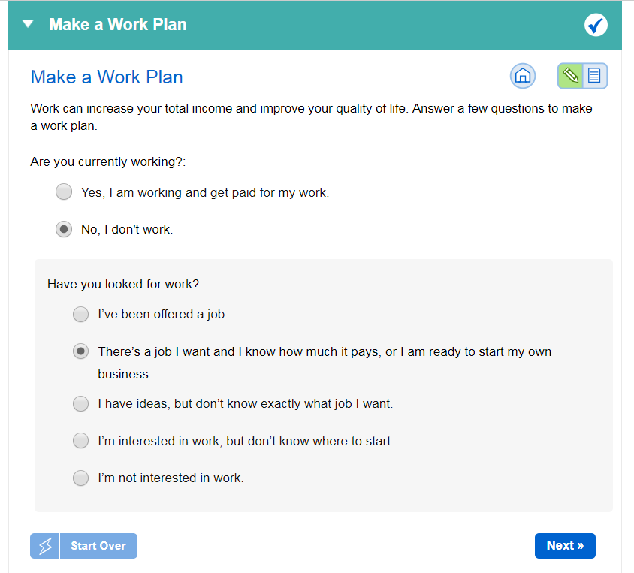
  - Future work and earnings goal(s) you’ve talked about,
  - By this time, you should have used the DB101 Vault “Make a Work Plan” activity to document the earnings goal in the Vault. The goal in this report and on the “Make a Work Plan” activity should be the same.

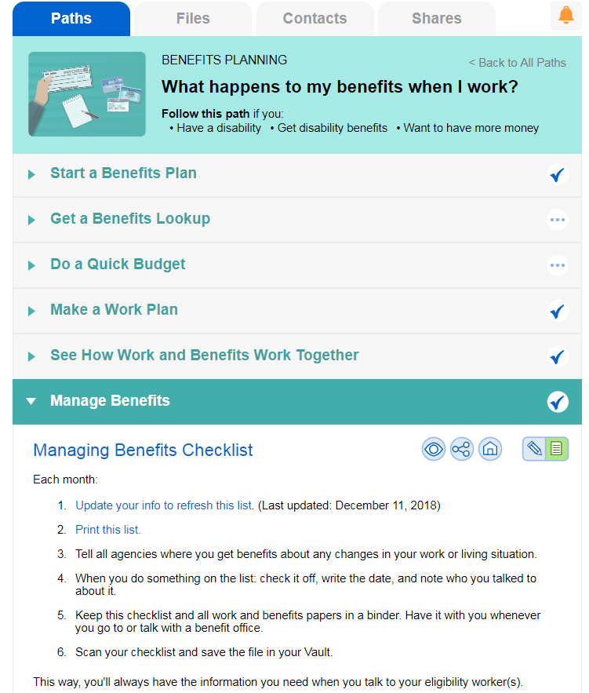
Managing Benefits & Reporting Your Income Section
- By this time, you should have complete the Managing Benefits activity in the Vault. Copy and paste the information from the results of that activity into this section.

Next Steps section
- Always include “Carefully review this report,” “Contact (your name) when you have a job offer, a change in hours, or a change in pay,” and “Schedule meeting with (Hub mentor’s name) to review BS&A” with your name listed as person responsible.
- Include anything the person or someone on their team needs to do in the next few weeks or months to make sure benefits are stable and/or to help move toward their work goal.
  - Examples could include scheduling meetings; applying for a benefit; contacting the Social Security claims rep or county financial worker to report a change or correct an error; or talking to their VR counselor, case manager, teacher, family or someone else about their plans.

Important Things to Remember section
List anything that is important to call out that weren’t included anywhere else in the report. This could include things details about a specific work incentive, a reminder to pay attention to other family member’s benefits, information on other programs or benefit that might be helpful, etc.

Agencies That Can Help Section
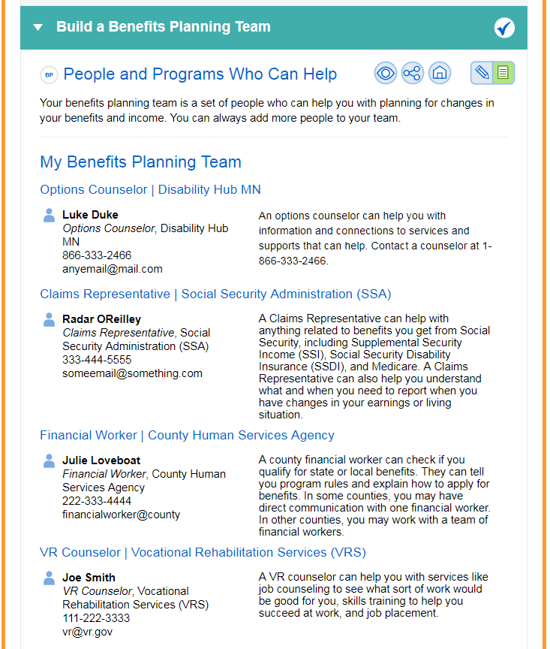
By this time, you should have completed the Build a Benefits Planning Team activity in the Vault. Use the information from the results of that activity to enter the agencies and individuals who can help the person reach their employment goal and/or deal with benefit issues here. Always include the Disability Hub MN and your agency.

My Contact Information Section
Enter your name, phone number and email address.

