General Instructions:
- Complete the Benefits Report for every client referral.
  - Share a copy of the Benefit report with the referral source and the person.
- The original Benefit Report is a template. It includes all of the most common information related to benefits and work.
Be sure to:
  - Delete information or entire sections of this report that are not applicable to the client.
  - Read through the ENTIRE document before printing or sharing to make sure all template text has been removed.
- It is important to begin with a new template rather than editing one previously saved when creating a new Benefit Report.
- Use the “Find & Replace” feature to easily find the brackets [ ] and enter the correct information throughout the entire document.
  - E.g., [earnings goal 1] find all and replace with the person’s actual earnings goal.
- This document has been made accessible (alt text descriptions have been added to the charts and text boxes). However, if you are working with a person who uses a screen reader or other device to help with reading/vision, it is recommended you remove the charts and text boxes and simply type the information as text in the Word document.

Section-by-section Instructions:

Cover Page “Snapshot”
- Enter the client’s name, your agency name, and your name
- Enter at least one earnings goal and fill in the snapshot information.
- Note: Best practice is to include two earnings goals, whenever possible.

Your Current Situation & Work Plans Section
- Your Current Benefits:
  - List all of the agencies you verified benefits with. Most often you will list the Department of Human Services and Social Security, but may also have others like a housing authority, landlord, Veteran’s Affairs, etc.
  - Remove any agencies that are listed in the template text that you did not contact.
  - List all of the benefits you verified, and remove any of the benefits they do not get.
  - If they get a benefit you were not able to verify, include the benefit with a note that you were not able to verify it with any agency. Connect with the Hub if you are not sure if you should include the benefit in the Estimator or the Report.
- Your Work Plans: Include a description of
  - Their current work, if any
  - Employment services they get (such as VR or employment specialist supports),
  - Help they’ve said they need, (always include “Help understanding what happens to my benefits when I go to work.”),

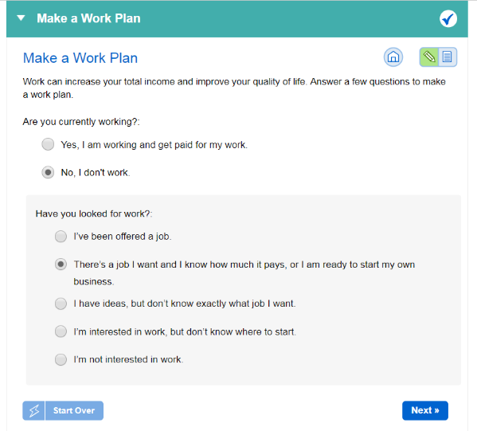
  - Future work and earnings goal(s) you’ve talked about,
  - Use the DB101 Vault “Make a Work Plan” activity to document the earnings goal in the Vault.

Your Cash Benefits & Work Section
- Use information you get from the DB101 Benefits & Work Estimator Session Results “Monthly Income/Expense” tab to fill in the “impact of earnings” on each benefit.
  - Talk to the Hub if you don’t understand how to read or interpret the Estimator results.
- Only include information listed in the template language. Keep it simple. If there is something important to tell them about the benefit or another benefit that might be helpful, include it in the “Important Things to Remember” section.
- You may also need to include information you get through conversation, documentation and the Vault to complete this section of the report.

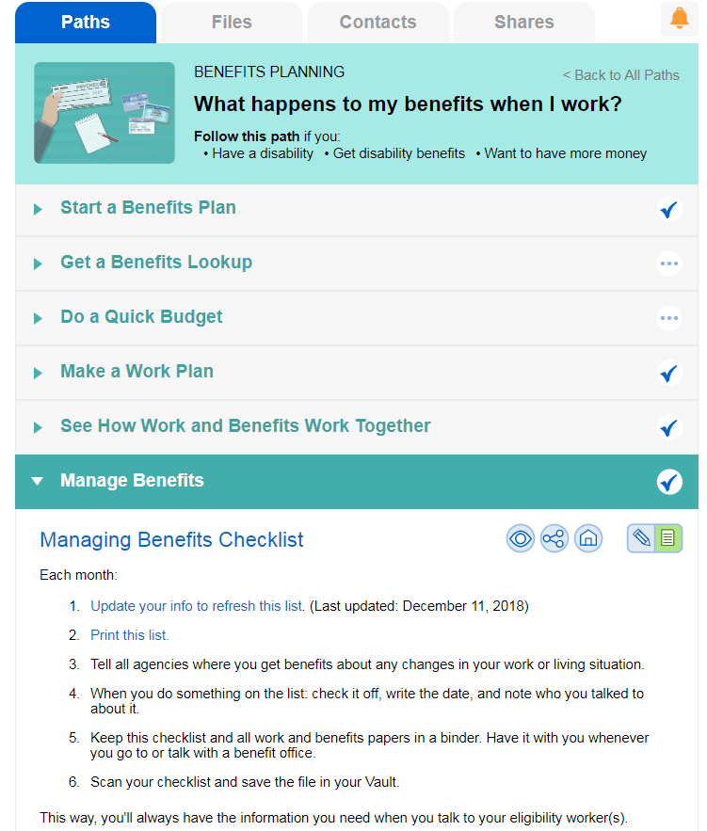
Managing Benefits & Reporting Your Income Section
- Complete the Managing Benefits activity in the Vault and copy and paste the information from the results into this section.

Next Steps section
- Always include “Carefully review this report” and “Contact (your name) when you have a job offer”
- Include anything the person or someone on their team needs to do in the next few weeks or months to make sure benefits are stable and/or to help move toward their work goal.
  - Examples could include scheduling meetings; applying for a benefit; contacting the Social Security claims rep or county financial worker to report a change or correct an error; or talking to their VR counselor, case manager, teacher, family or someone else about their plans.

Important Things to Remember section
List anything that is important to call out that weren’t included anywhere else in the report. This could include things details about a specific work incentive, a reminder to pay attention to other family member’s benefits, information on other programs or benefit that might be helpful, etc.

Agencies That Can Help Section
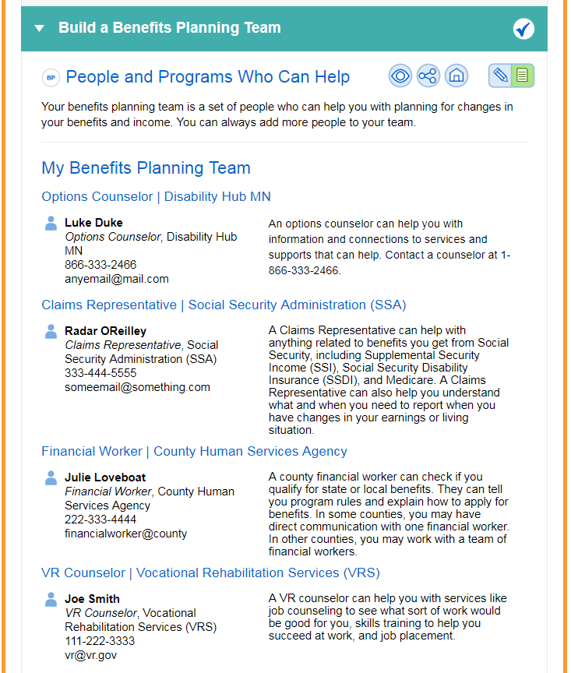
Complete the Build a Benefits Planning Team activity in the Vault. Use the information from the results of that activity to enter the agencies and individuals who can help the person reach their employment goal and/or deal with benefit issues here. Always include the Disability Hub MN and your agency.

My Contact Information Section
Enter your name, phone number and email address.

